Full Stack Development with MERN
Project Documentation format
1. Introduction
• Project Title: ShopEZ:One-Stop Shop for Online Purchases
• Team Members And Roles:
Name | Roles
Thathireddy Lokitha | Full Stack Developers(Backend & Frontend)
Yadavakunta Pradeep Reddy | Full Stack Developers(Backend & Frontend)
M Sai Dhiraj Kumar | Database & Payment Integration

2. Project Overview
Purpose :
- To develop a secure ecommerce web application using the MERN stack.
- To provide a smooth and user-friendly online shopping experience.
- To implement secure authentication using JWT and password encryption.
- To enable efficient product, cart, and order management.
- To integrate a secure online payment system using Razorpay.
- To design a scalable architecture using MongoDB Atlas.
Goals:
- To build a fully functional full-stack ecommerce application using MERN.
- To ensure secure user authentication and authorization.
- To implement efficient product browsing and search functionality.
- To enable smooth cart and order processing.
- To integrate secure online payment processing.
- To provide an admin panel for product and order management.
- To design a scalable and maintainable system architecture.
Features and Functionalities:
Authentication:
- User registration with email validation
- Secure login with JWT token
- Password hashing using bcrypt
- Role-based access (Customer / Admin)
- Profile management
- Protected API routes
Product Management:
- Add new product (Admin)
- Update product details
- Delete product
- View product listing
- View product details
- Basic search and category filtering
Cart Management:
- Add product to cart
- Update product quantity
- Remove product from cart
- Real-time total calculation
- Cart data persistence
Order Management:
- Create order from cart
- Generate unique order ID
- Store order details
- View order history
- Order status tracking
Payment Processing:
- Razorpay order creation
- Payment verification
- Payment success handling
- Payment failure handling
- Update order payment status
Admin Features:
- Admin login
- Manage products
- View users
- Monitor orders
Review Functionality:
- Add product review
- View product ratings
3. Architecture
Frontend:
1. Technology Stack
- React.js (UI Development)
- Vite (Fast build tool)
- Tailwind CSS (Styling)
- Axios (API communication)
- React Router (Client-side routing)
2. Architecture Design
Component-Based Structure
- Reusable components (Navbar, ProductCard, CartItem, etc.)
- Page-level components (Login, Register, Home, Cart, Orders, Admin
Dashboard)
3. State Management
- useState and useEffect hooks
- Local state for forms and UI updates
- Token stored in localStorage for authentication
4. Routing
- Public Routes (Login, Register)
- Protected Routes (Cart, Orders, Admin)
- Role-based access using JWT
5. API Communication
- Axios used for sending HTTP requests
- Backend endpoints connected through REST APIs
- Token attached in Authorization header
6. UI Design
- Responsive layout
- Mobile-friendly design
- Clean and minimal interface
Backend:

Server Layer
- Express server handles HTTP requests
- Middleware for JSON parsing and error handling
- API routes defined under /api
Route Layer
Separate route files for better modularity:
- Auth Routes
- Product Routes
- Cart Routes
- Order Routes
- Payment Routes
- Admin Routes
Each route connects to its respective controller.
Controller Layer
- Contains business logic
- Handles request and response
- Performs validation
- Communicates with database
Middleware Layer
- JWT Authentication Middleware
- Role-Based Authorization
- Error Handling Middleware
Ensures secure and controlled API access.
Database Layer
- MongoDB Atlas (Cloud Database)
- Mongoose schemas for:
  - Users
  - Products
  - Orders
  - Cart
  - Payments
Payment Integration Layer
- Razorpay SDK integration
- Order creation
- Payment verification
- Signature validation
Security Implementation
- JWT token validation on protected routes
- Password hashing using bcrypt
- Role-based access control (Admin / User)
• Database:
- MongoDB Atlas cloud database
- Collections: Users, Products, Cart, Orders, Payments
- Data stored in JSON format using Mongoose schemas
- CRUD operations: save(), find(), update(), delete()
- Relationships handled using ObjectId references
- Secured with JWT authentication & bcrypt password hashing
4. Setup Instructions
Prerequisites:
- Node.js (v16+ recommended)
- MongoDB Atlas account (or local MongoDB)
- Razorpay Account (for payment integration)
- VS Code
- Git
Installation Steps
1.Clone the Repository
git clone <repository-url>
cd shopez
2.Backend Setup
cd server
npm install
Create .env file inside server folder:
PORT=5000
MONGO_URI=your_mongodb_connection_string
JWT_SECRET=your_secret_key
RAZORPAY_KEY_ID=your_key
RAZORPAY_SECRET=your_secret
3.Frontend Setup
cd client
npm install
4.Run the Application
▶ Start Backend
npm start
▶ Start Frontend
npm run dev
Now application runs on:
- Backend → http://localhost:5000
- Frontend → http://localhost:5173
5. Folder Structure
Client (React Frontend Structure)
frontend/
├── src/
│ ├── pages/ → Page components (Home, Login, Cart, Orders)
│ ├── components/ → Reusable UI components (Navbar, ProductCard)
│ ├── api/ → Axios API calls
│ ├── context/ → Global state management
│ └── App.jsx → Main routing file
├── package.json
└── vite.config.js
Server (Node.js Backend Structure)
server/
├── models/ → Mongoose schemas (User, Product, Order)
├── routes/ → API route definitions
├── controllers/ → Business logic
├── middleware/ → JWT auth & error handling
├── config/ → Database connection
└── server.js → Main entry file

6. Running the Application

cd server && npm start
cd client && npm run dev (or npm start if using CRA)
7. API Documentation
Backend API (Simple Version)
Auth
- POST /auth/register → Create account
- POST /auth/login → Login & get token
Products
- GET /products → View products
- POST /products → Add product (Admin)
- PUT /products/:id → Update
- DELETE /products/:id → Delete
Cart
- POST /cart → Add item
- GET /cart → View cart
Orders
- POST /orders → Place order
- GET /orders → View orders
Payment
- POST /payment/create-order
- POST /payment/verify

8. Authentication
- Passwords are hashed using bcrypt.
- On login, backend generates a JWT token.
- Token is sent in request headers for protected routes.
- Backend verifies token before giving access.
- User roles (Admin/User) control permissions.
9. User Interface
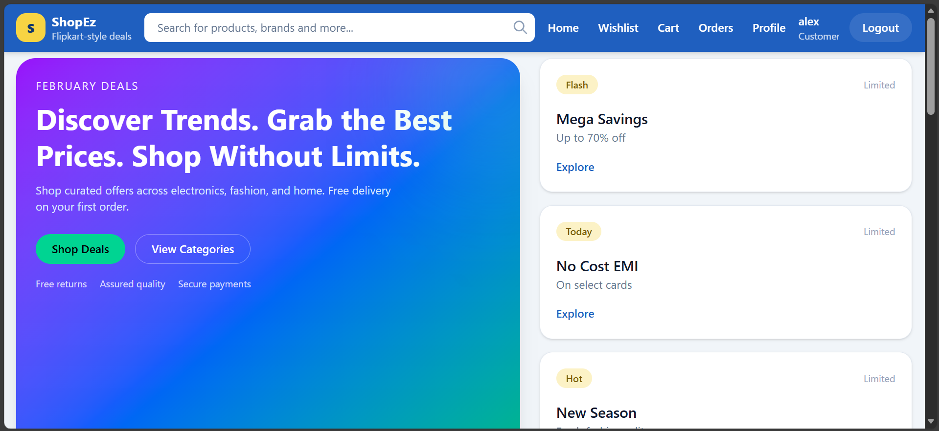
10. Testing
- Manual Testing → All features (login, cart, order, payment) manually test chesam
- API Testing → Backend APIs ni Postman lo test chesam
- Frontend Testing → Browser lo UI validation & form checks
- Authentication Testing → Invalid token & role-based access test chesam
- Payment Testing → Razorpay test mode lo payment verification chesam
Tools Used
- Postman
- Chrome Browser
- MongoDB Atlas (DB verification)

